DAC COM - FRP/PRESCRIBING UPDATE – APRIL 2007

As the new financial year begins, it is evident how hard our practices have worked towards achieving the Financial Recovery Plan to-date. We are hoping to continue this work throughout 07-08 to prescribe more cost-effectively and make further savings.

In addition to newer prescribing projects which will be introduced throughout the year, we are still concentrating on the areas where the most savings have been made throughout 06-07.

STATINS
Remember, the EoE SHA target is for 80% of all Statin prescribing to be generic Simvastatin.

How well is your practice doing?
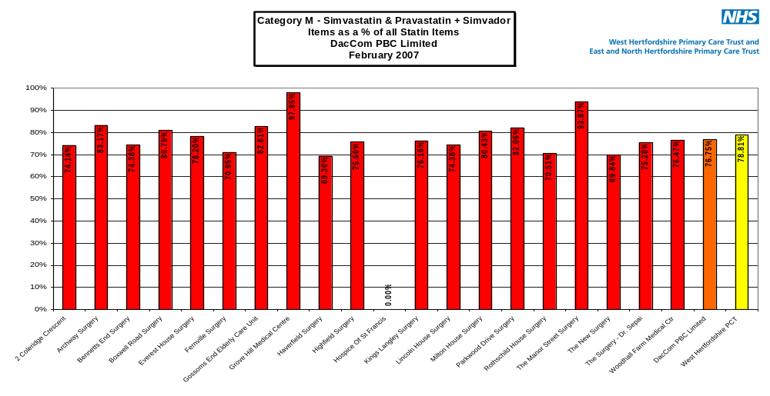

**** Please ensure that all appropriate new patients are being initiated with Simvastatin *****

PPIs
Even though this area is old news, it still generates one of the greatest amounts of savings without jeopardising patient care in any way. Hence it is extremely important that the products of choice remain Omeprazole or Lansoprazole CAPSULES. (EoE SHA target = 90%)
Are you aware that omeprazole tablets are three times more expensive than capsules?

How well is your practice doing?
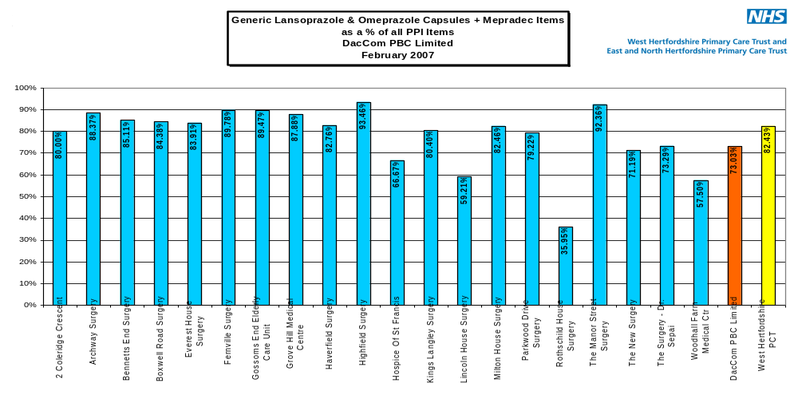

ALENDRONIC ACID
DacCom could potentially save £50,000 per year simply by making the following changes:

Current drug changed to Alendronic Acid 70mg, 1/week | Saving per 28 days | Saving per year per patient
Risedronate 35mg 1/week | £12.99 | £168.87
Fosamax 70mg 1/week | £15.49 | £201.37
Alendronic Acid 10mg 1/day | £20.61 | £267.93

ACTION:
As £20,000 could simply be saved by changing branded Fosamax® to generic Alendronic Acid, can we ask all practices to conduct a search on Fosamax® and change them to their generic equivalent.

SARTANS
The switch project to Candesartan should be well underway by now. Just by changing our Losartan prescriptions to Candesartan, DacCom could save upto £90,000 per year. Just think about how many ECG machines that could buy?

Has your practice progressed?
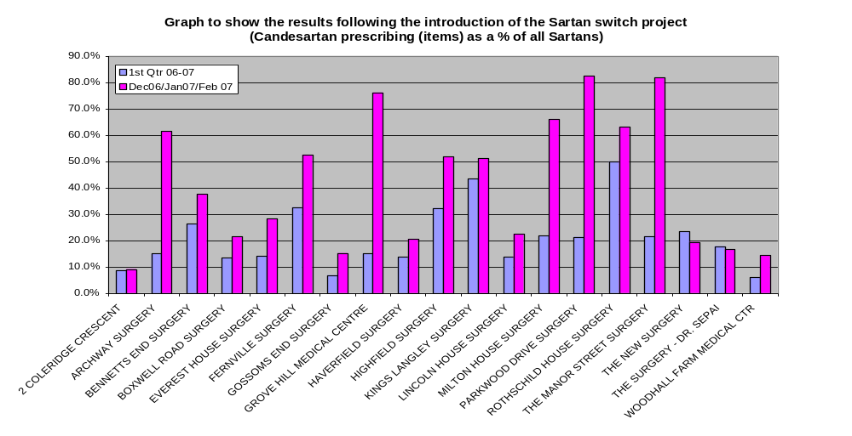

Remember pharmaceutical input is available from the Medicines Management Team if you would like to review or re-review any of the above areas in your practice.
Sapana Sheth can be contacted on 01923 281600 Ext 423

ANTI-HISTAMINES
It’s ‘hayfever’ season!! Please be aware that there is little difference between the older and newer anti-histamines, except their cost. Please try and prescribe, Loratidine, Cetirizine or Chlorphenamine, as far as possible or advise them to buy over-the-counter.

Whats Next????

GREY LIST
Have you received it???? If not please contact Sapana Sheth for your copy.
It is a list of medicines that should not normally be initiated/used in primary care and has been approved by the Joint Professional Executive Committee in December 2006. It is important that all GPs look at this document as explanations as to why certain drugs are included within this list are given.

Please be aware that 3 of the drugs which are increasing in use and are included on this list are:
(1) Losartan (2) Escitalopram (3) Pregabalin

